105 Photoshop Working with colours & blending exercises

Selecting Colours

Photoshop allows you to move between two colours at a time. These are called Foreground and Background colours. One of these two colours will be active at all times depending on which colour is in the upper colour square on the toolbar. The colour that is active can be applied to any selected area.
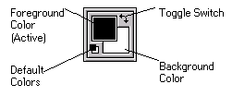

To select a colour, you must open the Colour Picker dialog box (Double Click on the foreground colour box) to select background colour (Double Click on the background colour box)

The Colour Picker dialog box provides three ways to choose and modify colours:
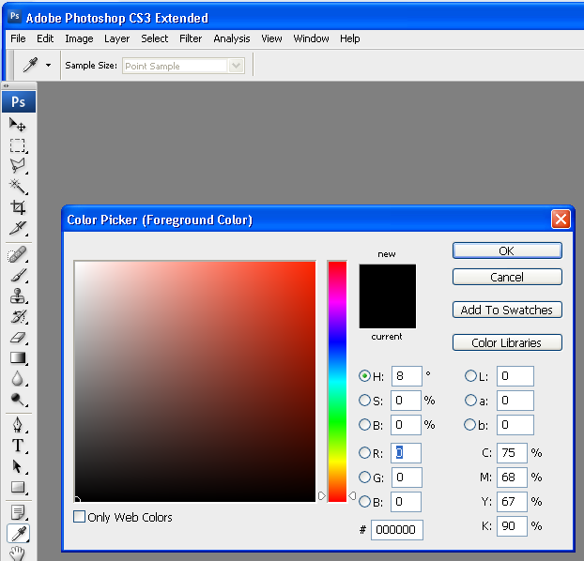
The Colour Field: Allows you to identify which colour will be added by moving a small circle that appears in the Colour Field. This circle can be moved by clicking around in the colour field you have 16.4 million choices.

The Colour Slider: Allows you to change the colour tone by moving the arrows up or down along the bar or by clicking inside the colour slider.

Numeric Values: Allows you to select a colour using numbers. Two groups of text boxes appear the HSB group and the RGB group.

Type values into either of the groups of text boxes and your new colour will be displayed in the rectangle above the text boxes.

2. Using the Colour Picker (dropper) you can select any colour from anywhere on the screen to select the desired colour

3. When you have decided on a colour, click OK
Your new colour now appears in the Foreground colour square on the toolbar.

Re-colouring Graphics

Photoshop allows you to recolor graphics easily. The active colour can be applied to any selected area of a graphic.

Changing an Image Colour Using the Fill Command

One way to change the colour of an image is by using the Fill command. The Fill command will fill any selected area with the active colour.

- Open colour.png
- 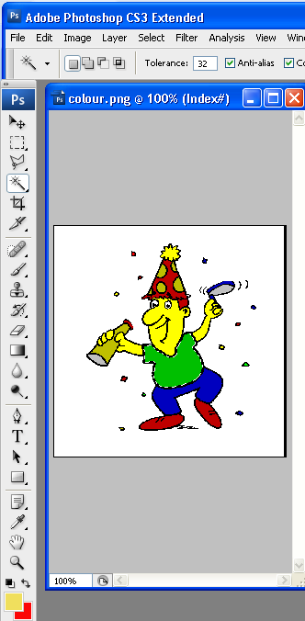

- Select a foreground colour

- Using the (Magic Wand) select the shirt and replace it with the foreground colour using Fill from the Edit menu.

- Continue to change all the colours using fill colours of your choice.

Applying Gradient Colour

- Open fruit.jpg (if it is not already open).

- Select your Background colour and choose a (Red) switch to the Foreground colour and (Use the eyedropper tool to select a yellow colour from the rose)

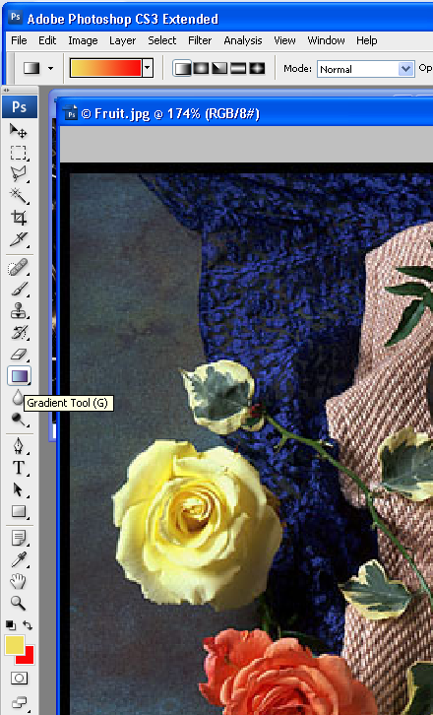
- These colours will be blended to create the colour gradient.

- On the fruit.jpg

- Select an apricot using the elliptical tool or magic wand and select the gradient tool, changing the opacity to 60%. Foreground to Background.

- Double-click the GRADIENT tool on the toolbar
The Gradient Options dialog box will appear.

- From the gradient menu, select one of the menu choices:

- Position the pointer over the place where you would like the gradient to begin

- Click the mouse button and drag over the image to where you would like the gradient to end Note you can go further outside if you wish

If you are unsatisfied with the gradient, use the Undo command and start again:
1. To undo the gradient, press [Ctrl]+[Z] (or use HISTORY)

Editing the Gradient

The Gradient tool will automatically blend the colours in the Foreground and Background positions, but you can change the colours as you wish.

Part 6 Dodging, burning and saturation exercise
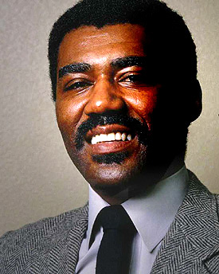

Dodge
- Open dodge.jpg and use the dodge tool to lighten the shadowed areas of the man’s face
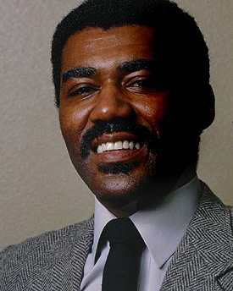

Burn
Open burn.jpg and use the burn tool to darken the highlighted areas of the man’s face.

Saturation

Open fruit.jpg.
- Use the sponge to saturate the colour of the orange rose and to de-saturate the colour of the yellow rose. Set selector to Saturate then to De-Saturate

Open sweets.jpg. Use the dodge and burn tools to improve the look of the picture.
- Select one sweet, and use the saturate and de-saturate options of the sponge to make it stand out from the others.

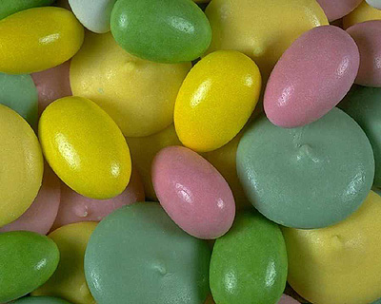

Sharpen and Blur Exercise
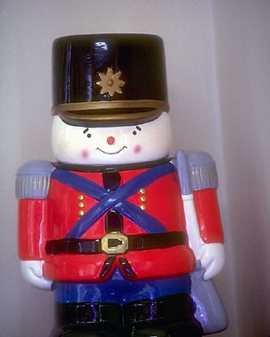

- Open sharpen.jpg and use the sharpen tool to increase the definition of the buttons on the image.

- Use the blur tool to soften any parts of the image that are oversharp.

Cloning Exercise

Use fruit.jpg and choose the rubber stamp tool and a brush size that is not too large..

- Repair the Pear - Option click on a good part of the pear (this selects a nice area of the Pear to clone). Move to the bruise on the pear and click the Rubber Cloning tool to replace the bruise with green.
Try with another object. Option Click this turns white and picks up the area
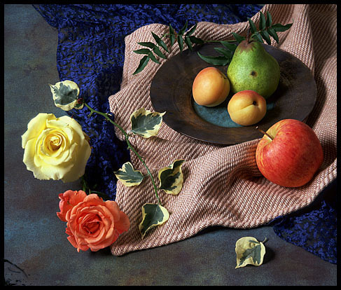
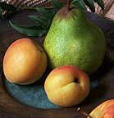

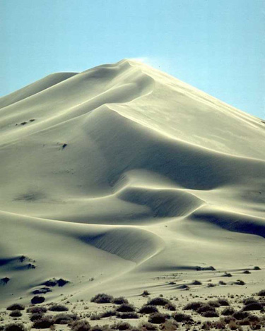

Tilt Exercise
- Open tilt.jpg select the area with the crop tool and rotate to correct the picture.

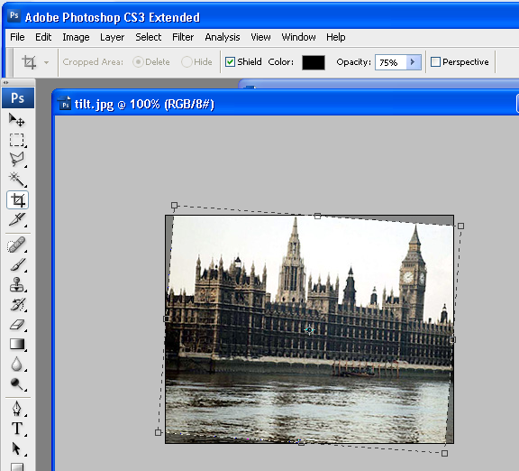

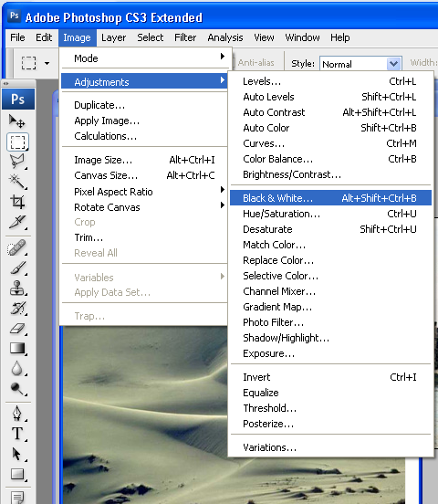

Or Try also Edit Transform

Part the last Image Mode Adjustments Exercise
- Open dune.jpg and convert it to a black and white photograph from the Image Adjustments Black & White
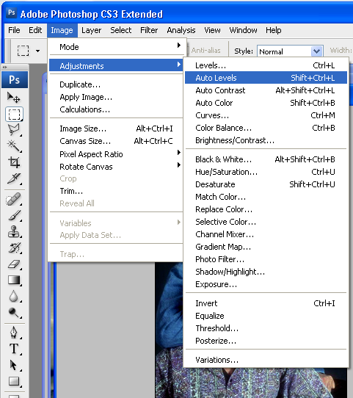

- Then revert it back to RGB and put a sepia tone over the picture.

- Open men.jpg and Use Image Adjustments to improve the image

- Use Image adjustments Curves to brighten the image
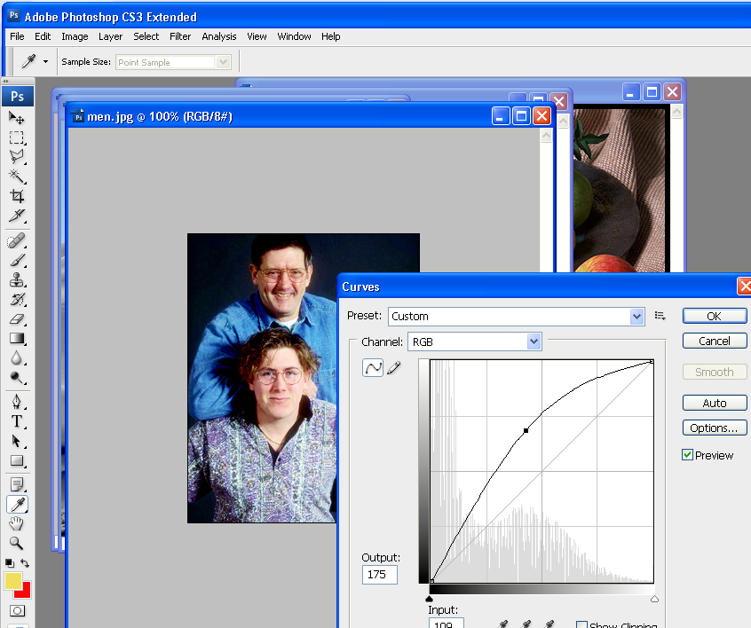
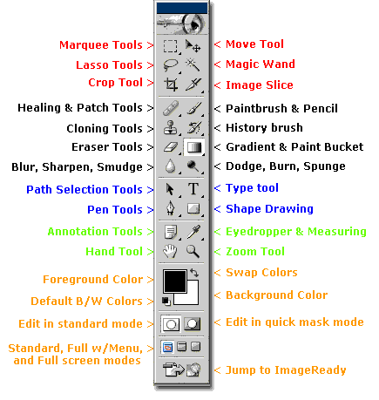

This Ends the Intro Session - Have fun with Session 3

